Homework

Assignment 1:

Section 2.5: 1(b) (Using Jacobi Method and Gauss-Seidel Method to calculate the first two iterations)

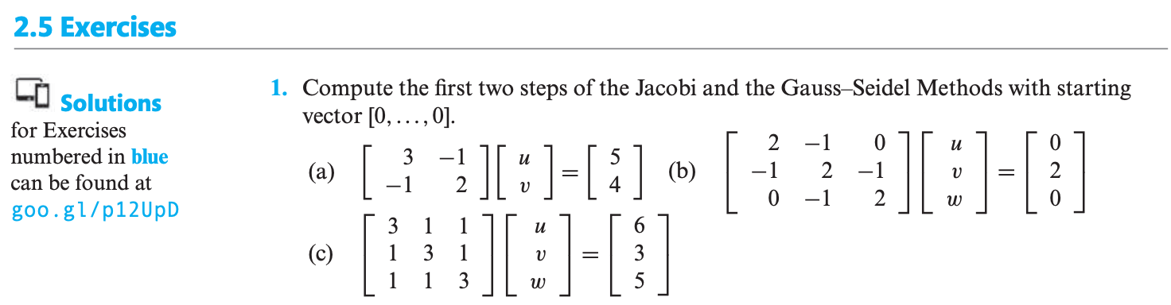

Assignment 2:

Section 2.6: 1(b) (Using the SOR Method to calculate the first two iterations, ω= 1.2, 1.5)

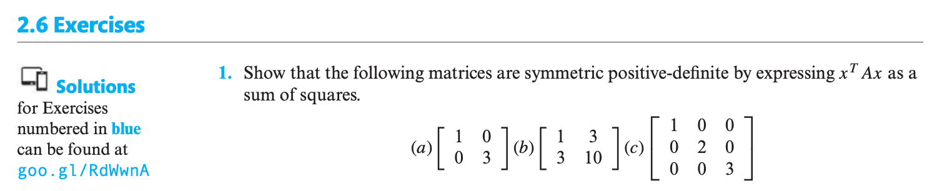

Assignment 3:

Section 2.6: 1(b), 2(b), 13(a)

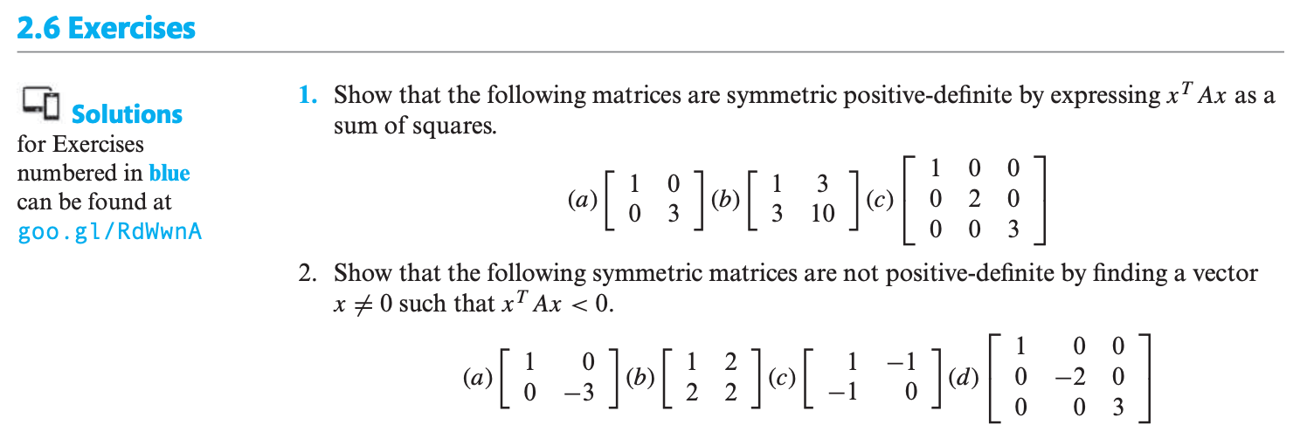



Assignment 4:

Reasoning the three items of THEOREM 2.16

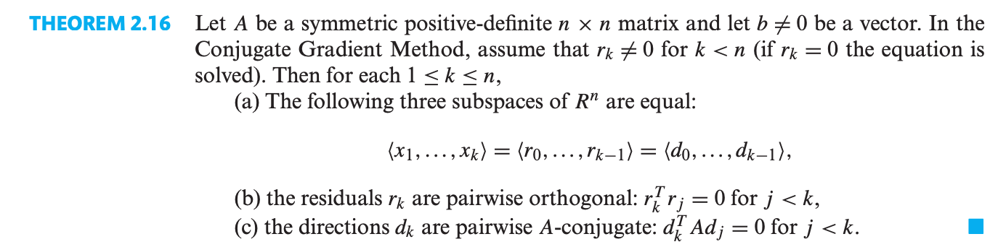

Assignment 5:

Section 3.1: 1(a) (Using the Lagrange interpolation and Newton’s divided difference formula to solve the problem)

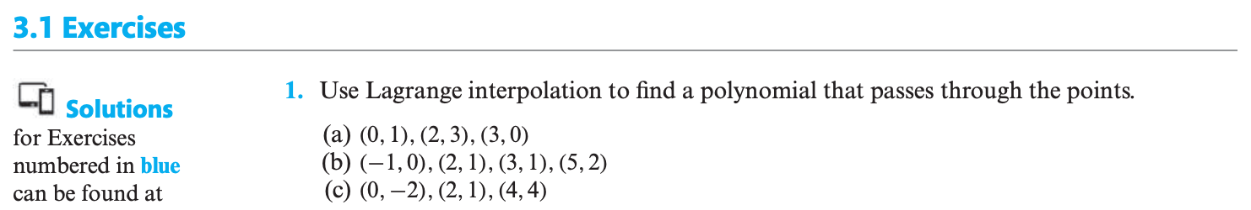

Assignment 6:

Section 3.2: 1, 2

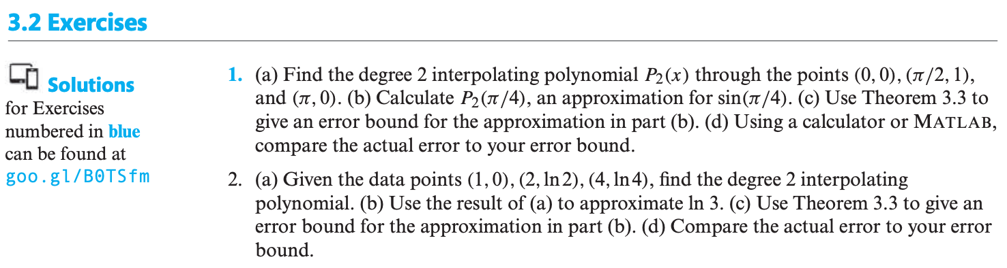

Assignment 7:

Section 3.3: 1(a) (Additionally compute the upper bound of ||);

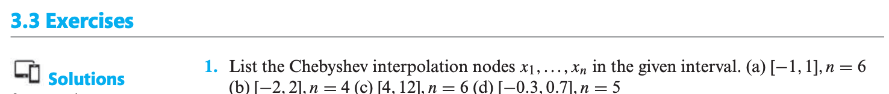

Assignment 8:

Section 4.1: 1(a)

Section 4.2: 1(a), 3(a)

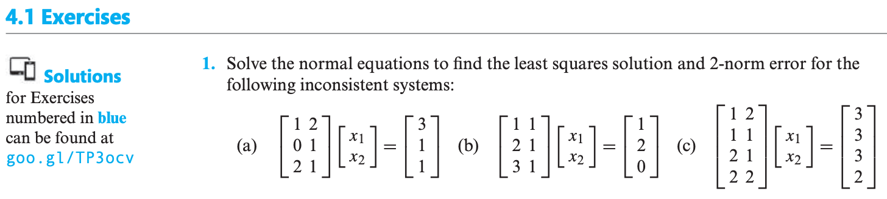

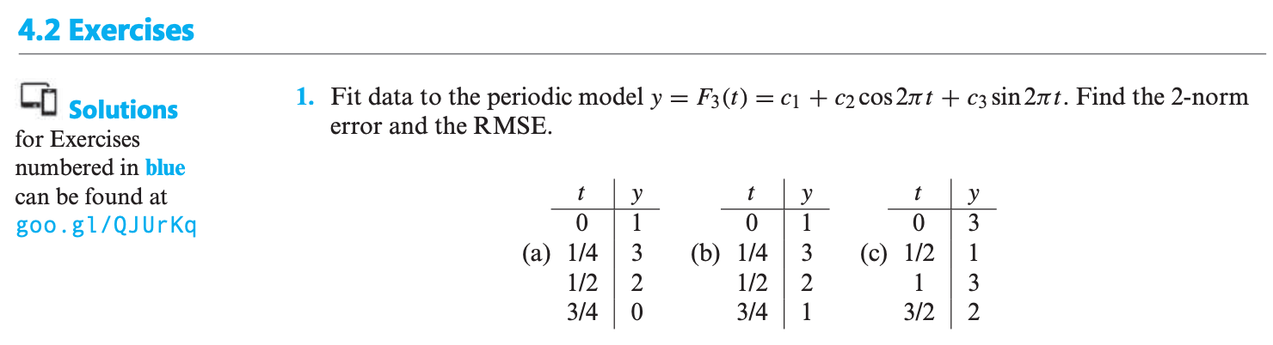



Assignment 9:

Section 4.3: 1(c)(Apply both classical Gram-Schmidt orthogonalization and Householder reflectors to find the full QR factorization of the matrices), 9

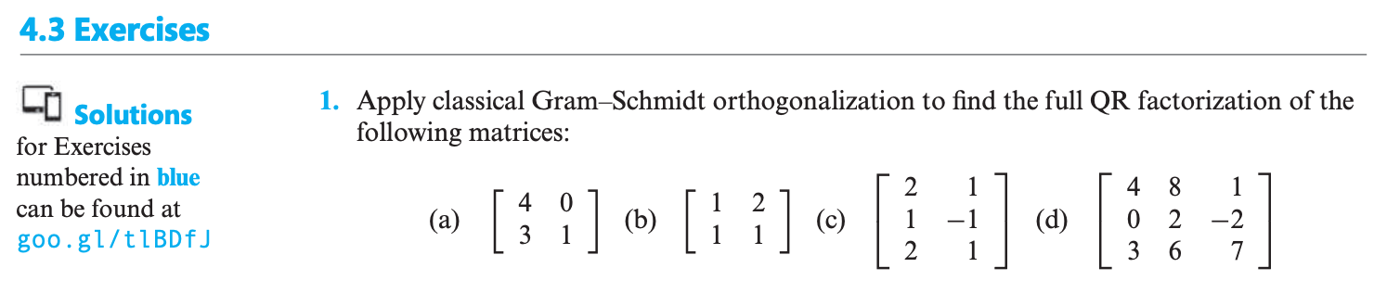



Assignment 10:

Section 12.2: 1(c)

Section 12.3: 1(c), 2(b)

